TRANSFERRING HEAT

Heat is transferred in three ways.

Conduction

• Occurs in solids where particles vibrate in fixed positions.
• Energy is transferred by particles colliding and transferring kinetic energy.
• As the amount of kinetic energy in the particles increases, a temperature rise if felt.

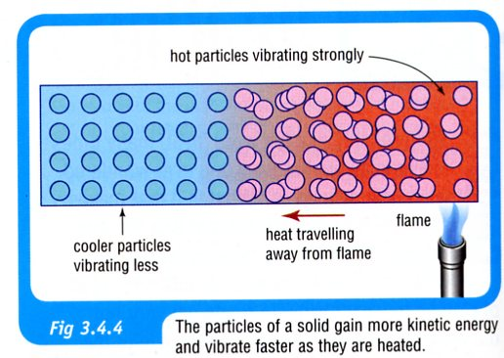
• Some substances are better conductors of heat than others.

e.g. Metals are very good conductors.
Plastics, glass, wood and other similar materials (non-metals) are insulators - very poor
conductors.

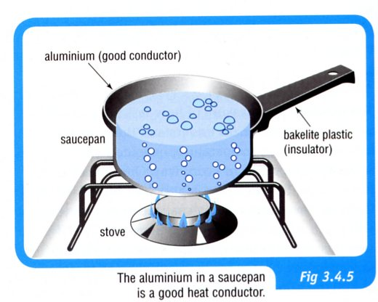

• Liquids and gases are very poor conductors - their particles are further apart and more
mobile so they collide far less.

Hence they use another method to transfer heat.

Convection

• Used to transfer heat in liquids and gases.
• Heated particles not only gain kinetic energy but they move further apart, becoming less
dense and rising to the top of the liquid or gas.
• Cooler, more dense liquid or gas moves in at the bottom to take the place of the rising
particles.
• Hot particles at the top start to cool and become denser, falling back down to the bottom.

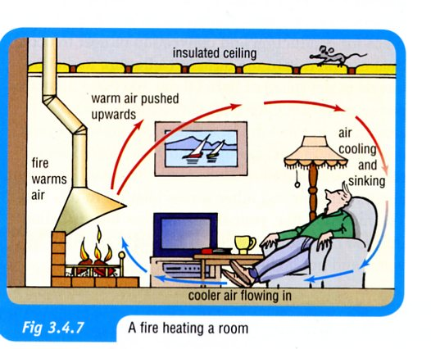

• Land and sea breezes are caused by unequal heating of the land and water.

i.e. If the sea is warmer, hot air rises over it and a land breeze moves out to sea.
If the land is warmer, a sea breeze moves in.

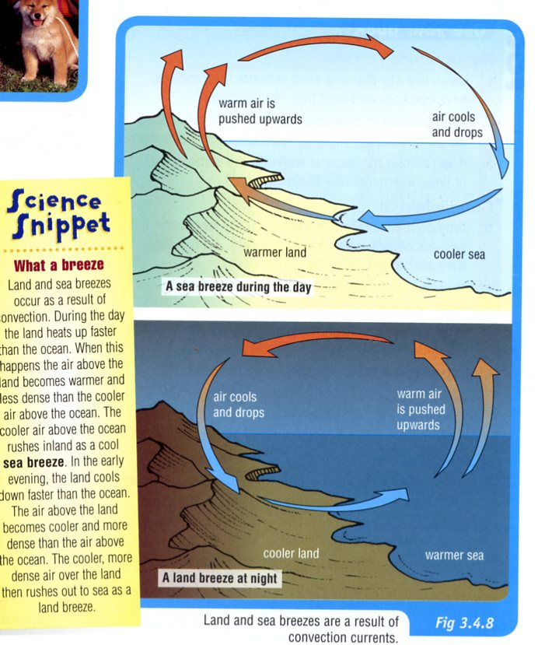

Radiation

• Heat is radiated from objects as infra-red light.
• Being light, it is able to be transmitted through space or the air at about 300,000 km/sec.
• All objects with heat in them will radiate the heat, and infra-red cameras and film will detect
them.
• Infra-red radiation can be reflected, absorbed or transmitted through objects or surfaces that it
hits.
• Black surfaces absorb and radiate heat better than lighter surfaces.

